
STUDENT RESULT SYSTEM
Cornerstone project work submitted to Aditya University in partial fulfilment of the requirements for the award of the Degree of
B.Tech. degree
in
Artificial Intelligence and Machine Learning (2026-2027)
Object Oriented Programming through C++ (2501CS08)
TEAM NUMBER – 09
P. SAI | 25B11AI908
M.M. NAGA SAI SRINIVAS | 25B11AI745
T. REVANTH | 25B11AIC03
P.V. SURYA HARSHA | 26B21AI099
SUBMITTED BY

In partial fulfilment of the requirements for the award of the B.Tech. degree in Artificial intelligence and machine learning the academic year 2026-2027.
Project Guide: Head of the Department:
Ms.T.Vijaya Lakshmi ( M.Tech) Dr.K.Naga Bhargavi,Ph.D
Assistant Professor Associate Professor&HOD
AIML Department Department of AIML

DECLARATION

I hereby declare that the Cornerstone project work entitled “STUDENT RESULT SYSTEM” is being submitted by me for the award of the B. Tech Degree in Artificial Intelligence and Machine Learning, Aditya University, Aditya Nagar, ADB Road, Surampalem is a record of original work carried out by us. We further declare that this project work has not been submitted, either in full or in part, for the award of any degree or diploma in this or any other institution. We also confirm that this work has been carried out with academic honesty and complies with the Institutional Academic Integrity and AI Usage Policy.

Submitted By
P. SAI | 25B11AI908
M.M.NAGASAI SRINIVAS | 25B11AI745
T. REVANTH | 25B11AIC03
P.V. SURYA HARSHA | 26B21AI099

Place: Surampalem
Date:

CERTIFICATE
This is to certify that the cornerstone project entitled “STUDENT RESULT SYSTEM” is being submitted by P. SAI, M.M. NAGA SAI SRINIVAS, T. REVANTH AND P.V. SURYA HARSHA in partial fulfilment for the award of B. Tech Degree from Aditya University, is a record of original work done by them under my supervision. The contents of this project, in full or in parts, have not been submitted to any other Institute or University for the award of any degree or diploma.

Project Guide
Ms.T.VIJAYALAKSHMI
Assistant Professor
Department of AIML
Aditya University

ACKNOWLEDGEMENT
It is with immense pleasure that we express our sincere gratitude to our Cornerstone Project Guide, Ms.T.Vijaya Lakshmi, M.Tech ,Assistant Professor, who has guided us throughout the project. Her valuable support, encouragement, and guidance have greatly contributed to the successful completion of this work.
We would like to thank our Deputy Heads of the Department Dr. R. Suneetha, Assistant Professor, Dr.Bollu Manikyala Rao, Associate Professor AND Dr.D.Veeraswamy, Associate Professor, Department of CSE, for their support and valuable suggestions.

Our deepest thanks to our Head of the Department, Dr. . K.Naga bargavi, DESIGNATION & HOD, for her inspiration and for providing all the necessary facilities and resources required for this project.

We also extend our sincere thanks to DR. M.V. RAJESH, ASSOCIATE DEAN, SCHOOL OF COMPUTING, for his encouragement and support during our project.

We would like to express our sincere gratitude to DR. G. SURESH, REGISTRAR; DR. A. RAMESH, PRO VICE-CHANCELLOR (ENGINEERING & SCIENCES); DR. S. RAMA SREE, PRO VICE-CHANCELLOR (ACADEMICS); DR. M.B. SRINIVAS, VICE-CHANCELLOR; AND DR. M. SREENIVASA REDDY, DEPUTY PRO CHANCELLOR AND MANAGEMENT, ADITYA UNIVERSITY, for providing excellent infrastructure and state-of-the-art laboratories.
`
Finally, we would like to thank the FACULTY MEMBERS, LAB TECHNICIANS, NON-TEACHING STAFF, AND OUR FRIENDS who have directly or indirectly supported us in completing this Cornerstone project successfully.

ABSTRACT
The Student Result System is a C++ based application developed to simplify and automate the management of student academic results. The system stores student details such as roll number, name, and marks in different subjects and automatically calculates total marks, average, percentage, grade, and pass or fail status. It provides a menu-driven interface through which users can add student records, display all results, search for a particular student, identify topper(s), and display all failed students. The system also includes input validation and duplicate roll-number checking to improve data accuracy. The project demonstrates important Object-Oriented Programming concepts such as classes, objects, encapsulation, arrays, and function modularization. The system reduces manual calculation effort and provides a simple and organized approach to student result management.

ABBREVATIONS
C++ – C Plus Plus
OOP – Object-Oriented Programming
ER – Entity Relationship
DFD – Data Flow Diagram
UI – User Interface
ID – Identification
PPT – PowerPoint Presentation

LIST OF FIGURES
Figure 1: System Architecture
Figure 2: Student Result System Flowchart
Figure 3: Student Result System Main Menu
Figure 4: Add Student Output
Figure 5: Display All Results Output
Figure 6: Search Student Output
Figure 7: Topper(s) Output
Figure 8: Failed Students Output
Figure 9: Exit Output
LIST OF TABLES
Table 1: Planned Modules
Table 2: Student Data Fields
Table 3: Grade Calculation Criteria

TABLE OF CONTENTS

CONTENTS | PAGE NO
Title Page | I
Declaration | II
Certificate | III
Acknowledgement | IV
Abstract | V
Abbreviations | VI
List of Figures | VII
List of Tables | VIII
CHAPTER -1 Project Planning | 1
1.1. Problem statement | 1
1.2. Project Objective | 1
1.3. Planned Modules | 2
1.4. System Architecture (Algorithm & Flowchart) | 2
CHAPTER -2 Project Implementation | 6
2.1. OOP Concepts Used for implementation | 6
2.2. Code | 6
2.3. Output Screens | 13
CHAPTER-3 Conclusion & Future Scope | 16
3.1. Conclusion | 16
3.2. Future Scope | 16

CHAPTER – 1: PROJECT PLANNING
1.1 Problem Statement
Managing student academic results manually requires considerable time and effort. Faculty members need to enter marks, calculate total and average marks, determine percentages and grades, and identify pass or fail status for each student. Manual processing can also lead to calculation errors and difficulty in maintaining and searching student records.
The Student Result System is developed to provide a simple computerized solution for managing student academic results. The system allows users to enter student details and marks, automatically calculate the required result information, search for student records, identify topper(s), and display all failed students.

1.2 Project Objective
The main objective of the Student Result System is to develop a simple and efficient C++ application for managing student academic results.
The major objectives are:
- To store student details using classes and objects.
- To accept marks for different subjects.
- To calculate total marks, average, and percentage.
- To automatically determine grades.
- To identify Pass or Fail status.
- To display all student results.
- To search for a student using the roll number.
- To identify the topper or multiple toppers.
- To display all failed students.
- To validate user inputs.
- To prevent duplicate roll numbers.
- To demonstrate practical use of C++ Object-Oriented Programming concepts.

1.3 Planned Modules
Table 1: Planned Modules
Module | Description
Student Management | Add and store student details such as roll number, name, and marks in three subjects.
Result Processing | Calculate total marks, average, percentage, grade, and pass/fail status for each student.
Result Display | Display the complete results of all students with their marks, grade, percentage, and result status.
Student Search | Search for a particular student using the roll number and display the complete result details.
Topper Identification | Find and display the student or students who have achieved the highest average marks.
Failed Student Identification | Identify and display all students who have failed in the examination.
Input Validation | Validate menu choices, marks, and roll numbers to ensure correct and valid data entry.

Table 2: Student Data Fields
Field | Data Type | Description
rollNo | string | Unique roll number of the student (duplicates are rejected)
name | string | Name of the student
marks1, marks2, marks3 | float | Marks in C++, Python and DBMS (each between 0 and 100)
total | float | Sum of the three subject marks (out of 300)
average | float | Total marks divided by 3
percentage | float | Total marks divided by 300, multiplied by 100
grade | string | Grade awarded (O, A+, A, B, C or F)
result | string | PASS or FAIL

1.4 System Architecture
The Student Result System follows a simple layered structure.
USER
|
▼
MENU-DRIVEN INTERFACE
|
▼
STUDENT MANAGEMENT
|
▼
STUDENT CLASS / OBJECT
|
┌───────┼────────┐
▼ ▼ ▼
Marks Search Validation
|
▼
RESULT PROCESSING
|
┌─────┼──────┬──────────┐
▼ ▼ ▼ ▼
Total Average Grade Pass/Fail
|
▼
OUTPUT
Figure 1: System Architecture
The user interacts with the menu-driven interface. Student information is stored using objects of the Student class. The system processes the marks and generates the required result information. Finally, the processed information is displayed to the user.
Algorithm
Algorithm for Adding a Student
- Start the program.
- Select Add Student from the menu.
- Enter the student's roll number.
- Check whether the roll number already exists.
- If it exists, display an error message.
- Otherwise, enter the student name.
- Enter marks for the three subjects.
- Validate the marks.
- Store the student information.
- Display a successful record-added message.
- Return to the main menu.
Algorithm for Result Calculation
- Read the marks of all subjects.
- Calculate total marks.
- Calculate average marks.
- Calculate percentage.
- Determine the grade.
- Check the pass/fail condition.
- Store or display the calculated result.
Table 3: Grade Calculation Criteria
Condition | Grade | Result
Any subject mark below 35 | F | FAIL
Average 90 or above | O | PASS
Average 80 to below 90 | A+ | PASS
Average 70 to below 80 | A | PASS
Average 60 to below 70 | B | PASS
Average below 60 (all subjects 35 or above) | C | PASS

Algorithm for Searching a Student
- Enter the roll number to search.
- Compare it with the stored student roll numbers.
- If a match is found, display the student's complete result.
- If no match is found, display Student Not Found.
- Return to the main menu.
Algorithm for Finding Topper(s)
- Consider all student records.
- Calculate or use the average marks of each student.
- Find the highest average.
- Compare every student's average with the highest average.
- Display all students having the highest average.
Algorithm for Displaying Failed Students
- Check each student's result status.
- If the result is FAIL, select that student.
- Display the student's details.
- Continue until all student records are checked.

Flowchart
┌───────────┐
│ START │
└─────┬─────┘
│
▼
┌─────────────────┐
│ Display Main │
│ Menu │
└────────┬────────┘
│
▼
┌─────────────┐
│ Enter Choice│
└──────┬──────┘
│
┌───────────┼────────────┐
▼ ▼ ▼
Add Student Display Search
│ Results Student
│ │ │
▼ ▼ ▼
Store Display Find
Details Records Record
│ │ │
└───────────┼────────────┘
│
▼
Topper / Failed
Students
│
▼
Exit Chosen?
/ \
No Yes
│ │
└─────┐ ▼
│ ┌─────┐
└──►│ END │
└─────┘
Figure 2: Student Result System Flowchart

CHAPTER – 2: PROJECT IMPLEMENTATION
2.1 OOP Concepts Used for Implementation
Class
A class is a user-defined data type that groups related data and functions together. In our project, the Student class is used to represent student information and operations.
Object
An object is an instance of a class. Each student record can be represented using an object of the Student class.
Encapsulation
Encapsulation combines data and functions within a class and provides controlled access to the data. It helps keep the student information organized.
Functions
Functions are used to divide the program into smaller modules. Each function performs a specific task such as adding students, displaying results, searching, or calculating results.
Array of Objects
An array of Student objects is used to store multiple student records during program execution.
String Handling
Strings are used to store information such as student names and roll numbers.

2.2 Code
#include <iostream>
#include <iomanip>
#include <string>
#include <limits>
using namespace std;

class Student
{
private:
string rollNo;
string name;
float marks1, marks2, marks3;
float total, average, percentage;
string grade;
string result;

public:

// Set student basic information
void setBasicData(string r, string n)
{
rollNo = r;
name = n;
}

// Get and validate marks
float getValidMarks(string message)
{
float marks;

while (true)
{
cout << message;
cin >> marks;

if (cin.fail())
{
cout << "Invalid input! Please enter a number.\n";
cin.clear();
cin.ignore(numeric_limits<streamsize>::max(), '\n');
}
else if (marks < 0 || marks > 100)
{
cout << "Marks must be between 0 and 100.\n";
}
else
{
return marks;
}
}
}

// Get marks
void getMarks()
{
marks1 = getValidMarks("Enter Marks in c++: ");
marks2 = getValidMarks("Enter Marks in python: ");
marks3 = getValidMarks("Enter Marks in DBMS: ");
}

// Calculate result
void calculateResult()
{
total = marks1 + marks2 + marks3;
average = total / 3.0;
percentage = (total / 300.0) * 100;

// If any subject is below 35, student fails
if (marks1 < 35 || marks2 < 35 || marks3 < 35)
{
grade = "F";
result = "FAIL";
}
else
{
result = "PASS";

if (average >= 90)
grade = "O";
else if (average >= 80)
grade = "A+";
else if (average >= 70)
grade = "A";
else if (average >= 60)
grade = "B";
else
grade = "C";
}
}

// Display complete result
void display()
{
cout << "\n================================================";
cout << "\nRoll Number : " << rollNo;
cout << "\nName : " << name;

cout << "\n------------------------------------------------";

cout << "\nc++ : "
<< fixed << setprecision(0) << marks1;

cout << "\npython : "
<< fixed << setprecision(0) << marks2;

cout << "\nDBMS : "
<< fixed << setprecision(0) << marks3;

cout << "\n------------------------------------------------";

cout << "\nTotal Marks : "
<< fixed << setprecision(0)
<< total << " / 300";

cout << "\nAverage : "
<< fixed << setprecision(2)
<< average;

cout << "\nPercentage : "
<< fixed << setprecision(2)
<< percentage << "%";

cout << "\nGrade : " << grade;
cout << "\nResult : " << result;

cout << "\n================================================\n";
}

// Display short failed-student details
void displayFailedStudent()
{
cout << "\n-----------------------------------------------";
cout << "\nRoll Number : " << rollNo;
cout << "\nName : " << name;
cout << "\nAverage : "
<< fixed << setprecision(2) << average;
cout << "\nGrade : " << grade;
cout << "\nResult : " << result;
cout << "\n-----------------------------------------------";
}

// Get roll number
string getRollNo()
{
return rollNo;
}

// Get average
float getAverage()
{
return average;
}

// Check whether student failed
bool isFailed()
{
return result == "FAIL";
}
};

// Check duplicate roll number
bool rollNumberExists(Student students[], int count, string rollNo)
{
for (int i = 0; i < count; i++)
{
if (students[i].getRollNo() == rollNo)
{
return true;
}
}

return false;
}

int main()
{
Student students[50];

int count = 0;
int choice;

do
{
cout << "\n\n===============================================";
cout << "\n STUDENT RESULT SYSTEM";
cout << "\n===============================================";
cout << "\n1. Add Student";
cout << "\n2. Display All Results";
cout << "\n3. Search Student";
cout << "\n4. Display Topper(s)";
cout << "\n5. Display Failed Students";
cout << "\n6. Exit";
cout << "\n===============================================";

cout << "\nEnter your choice: ";
cin >> choice;

// Validate menu input
if (cin.fail())
{
cout << "\nInvalid input! Please enter a number from 1 to 6.";

cin.clear();
cin.ignore(numeric_limits<streamsize>::max(), '\n');

continue;
}

switch (choice)
{

// =====================================
// 1. ADD STUDENT
// =====================================

case 1:
{
if (count >= 50)
{
cout << "\nMaximum student limit reached!";
break;
}

string rollNo;
string name;

cout << "\nEnter Roll Number: ";
cin >> rollNo;

// Check duplicate roll number
if (rollNumberExists(students, count, rollNo))
{
cout << "\nError: Roll Number already exists!";
break;
}

cin.ignore(numeric_limits<streamsize>::max(), '\n');

cout << "Enter Student Name: ";
getline(cin, name);

// Store basic details
students[count].setBasicData(rollNo, name);

// Get marks
students[count].getMarks();

// Calculate result
students[count].calculateResult();

count++;

cout << "\nStudent record added successfully!";

break;
}

// =====================================
// 2. DISPLAY ALL RESULTS
// =====================================

case 2:
{
if (count == 0)
{
cout << "\nNo student records available!";
}
else
{
cout << "\n\n=========== ALL STUDENT RESULTS ===========";

for (int i = 0; i < count; i++)
{
students[i].display();
}
}

break;
}

// =====================================
// 3. SEARCH STUDENT
// =====================================

case 3:
{
if (count == 0)
{
cout << "\nNo student records available!";
break;
}

string searchRoll;

cout << "\nEnter Roll Number to Search: ";
cin >> searchRoll;

bool found = false;

for (int i = 0; i < count; i++)
{
if (students[i].getRollNo() == searchRoll)
{
students[i].display();

found = true;

break;
}
}

if (!found)
{
cout << "\nStudent not found!";
}

break;
}

// =====================================
// 4. DISPLAY TOPPER(S)
// =====================================

case 4:
{
if (count == 0)
{
cout << "\nNo student records available!";
break;
}

// Find highest average
float highestAverage = students[0].getAverage();

for (int i = 1; i < count; i++)
{
if (students[i].getAverage() > highestAverage)
{
highestAverage = students[i].getAverage();
}
}

cout << "\n\n============== TOPPER(S) ==============";

cout << "\nHighest Average : "
<< fixed << setprecision(2)
<< highestAverage;

// Display all students with highest average
for (int i = 0; i < count; i++)
{
if (students[i].getAverage() == highestAverage)
{
students[i].display();
}
}

break;
}

// =====================================
// 5. DISPLAY FAILED STUDENTS
// =====================================

case 5:
{
if (count == 0)
{
cout << "\nNo student records available!";
break;
}

int failedCount = 0;

cout << "\n\n============== FAILED STUDENTS ==============";

for (int i = 0; i < count; i++)
{
if (students[i].isFailed())
{
students[i].displayFailedStudent();

failedCount++;
}
}

if (failedCount == 0)
{
cout << "\n\nNo students have failed.";
}
else
{
cout << "\n\nTotal Failed Students : "
<< failedCount;
}

break;
}

// =====================================
// 6. EXIT
// =====================================

case 6:
{
cout << "\nThank you for using Student Result System!";

break;
}

// =====================================
// INVALID CHOICE
// =====================================

default:
{
cout << "\nInvalid choice! Please select 1 to 6.";

break;
}
}

} while (choice != 6);

return 0;
}
2.3 Output Screens
Figure 3: Main Menu Output
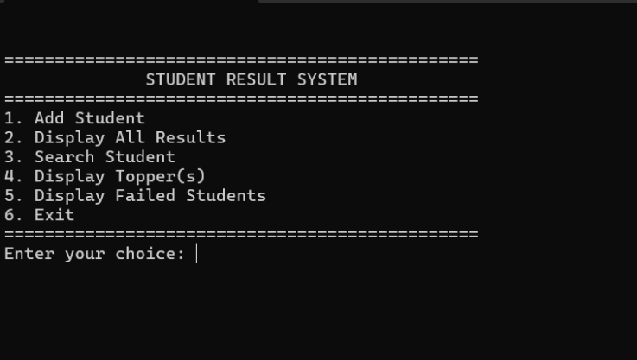

Figure 4: Add Student Output
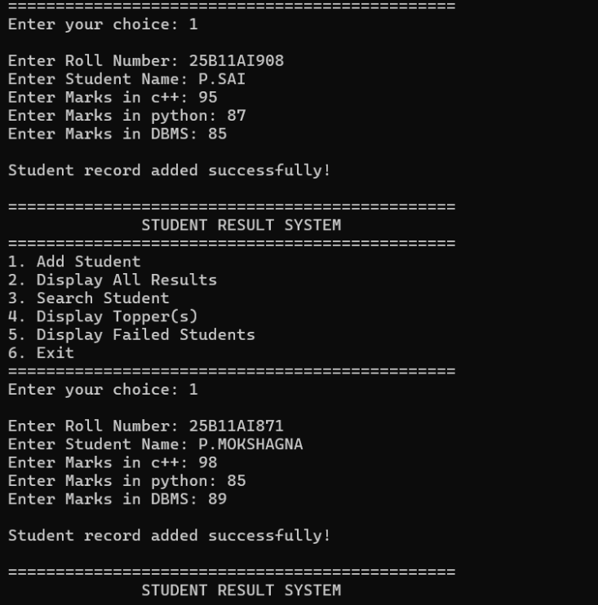

Figure 5: Display All Results Output
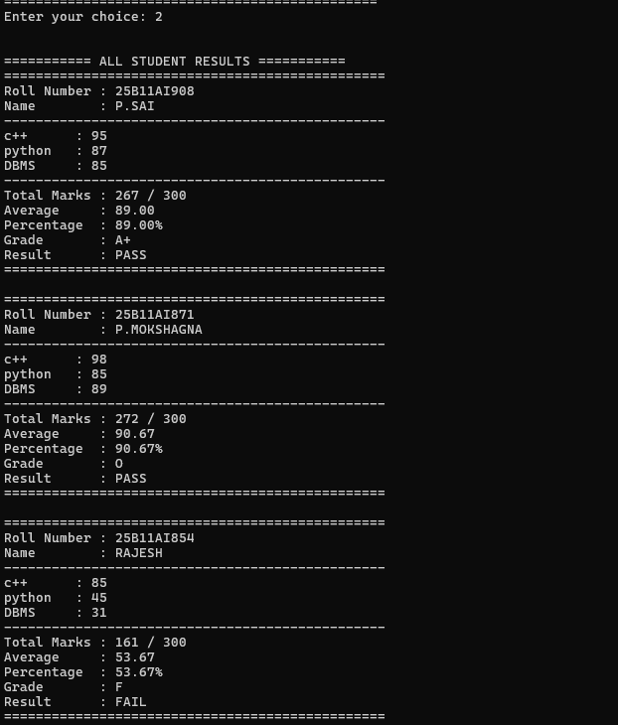

Figure 6: Search Student Output
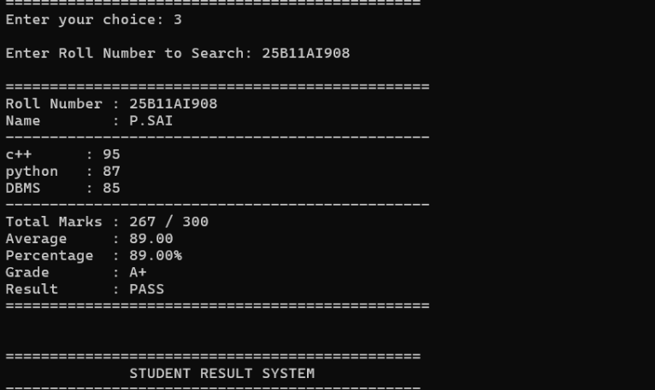

Figure 7: Topper(s) Output
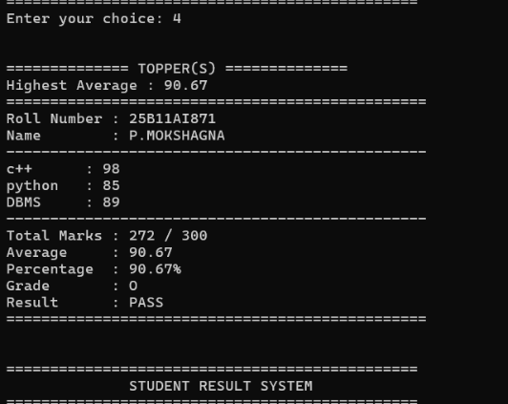

Figure 8: Failed Students Output
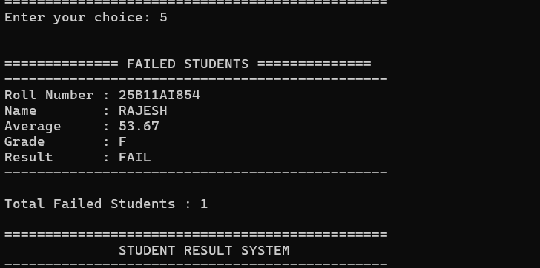

Figure 9: Exit Output
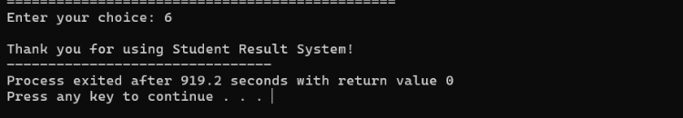

CHAPTER – 3: CONCLUSION & FUTURE SCOPE
3.1 Conclusion
The Student Result System was successfully developed using C++ and Object-Oriented Programming concepts. The system provides an organized way to manage student academic results and reduces the effort involved in manual calculations. It can add student records, calculate total marks, average, percentage and grade, display complete results, search for individual students, identify topper(s), and display failed students.
The project helped the team understand the practical implementation of classes, objects, encapsulation, functions, arrays, string handling, input validation, and modular programming. Overall, the system provides a simple and user-friendly approach to student result management.
3.2 Future Scope
The Student Result System can be further improved by adding several advanced features.
- File Handling: Student records can be permanently stored in files.
- Database Connectivity: A database can be used to store and manage large numbers of student records.
- Graphical User Interface: A GUI can make the system more attractive and easier to use.
- Login System: Separate login access can be provided for administrators, faculty, and students.
- Subject-wise Analysis: The system can provide detailed performance analysis for each subject.
- Report Generation: Student results can be generated as printable reports or PDFs.
- Online Access: The system can be developed as a web-based application for accessing results from different devices.

